Replace current ‘Speaking’ webpage content with the following:

80% of American adults have periodontal disease.
Yet, most practices report periodontal treatment rates of 15% - 30%.
Closing this gap is crucial to building a productive practice.


We now have irrefutable evidence that periodontal disease can have devastating eﬀects on systemic health. Comprehensive periodontal care results in improved systemic health and creates loyal patients who accept treatment and refer family and friends. This practice builder is a win-win for patients and care providers.
Kathryn Gilliam, RDH, BA, is passionate about empowering clinicians to incorporate science-based principles and a philosophy of treatment from the heart. Audiences applaud her readily implemented protocols and appreciate her ability to make complex information easy to understand.
- Increase your understanding of the science behind the oral-systemic link
- Gain easy-to-follow protocols to increase treatment eﬀectiveness, productivity, and profits
- Improve communication strategies and verbal skills to enhance patient compliance and optimize treatment outcomes
Elevate your identity as a healthcare provider, gain a renewed enthusiasm for your career, and develop the confidence to design your own wellness practice.

PRESENTATIONS
Hot Stuﬀ: The Dangers of Oral Inflammation

Explore the science behind the oral-systemic connection. Integrate salivary diagnostic testing, implement the latest adjunctive therapies, and master eﬀective communication skills to educate patients for improved case acceptance. Understand nutritional needs of periodontal patients, review the anti-inflammatory diet, and identify targeted nutritional supplements.
View Course Description
<link to inflammation.pdf in NEW window>

Oral Cancer: Three Minutes to Save a Life

In this interactive workshop, distinguish the risks of oral cancer and recognize those people at highest risk. Master a spa-like, comprehensive examination to set your practice apart. Review protocols for the management of cancer treatment side eﬀects. Acquire verbal skills to enhance patient education, increase acceptance, ease patient concerns, and maximize patient follow up.
View Course Description
<link to oral cancer.pdf in NEW window>

VIEW SPEAKER PACKET
<link to Gilliam Speaker Packet.pdf in NEW window>
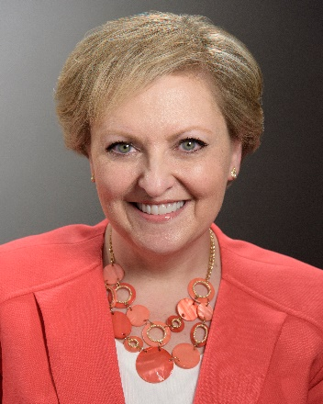
The origin of many systemic diseases can be found in periodontal disease.
Kathryn Gilliam’s interest in the medical side of dentistry led her to years of advanced study into the oral-systemic link, including graduating from the prestigious Bale Doneen Preceptorship. Her company, PerioLinks, LLC, was born out of her desire to train dental teams to transform their practices to care for the total health of their patients through comprehensive periodontal treatment.
Kathryn delivers impactful presentations to both small and large groups across the country and internationally.
View Kathryn’s Full Bio
<link to bio testimonials.pdf in NEW window>

Contact Kathryn to customize a presentation for your next meeting!
832-264-8343 - Kathryn@PerioLinks.com

